Music Genre Classification

Design Analysis   
  
Level 0

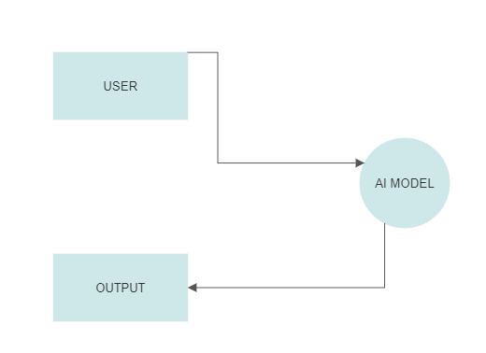

## Level 1

